

Intelligent Defense Systems: Applying Machine Learning and Deep Learning to Detect Ransomware Attack
By
Omar khalid
Sohip Foad
Mohammad Hani

Supervised by
Dr. Shorouq Al-Eidi

Computer Science Department
Faculty of Information & Communications Technology
Tafila Technical University
2024-2025

Acknowledgment
We are deeply thankful to everyone who contributed to the completion of this project. Their encouragement and assistance were crucial in helping us achieve this milestone.
First and foremost, we extend our deepest thanks to our supervisor, Dr. Shorouq Al-Eidi, whose mentorship and insightful recommendations were key to navigating this journey. Her expertise, patience, and dedication provided invaluable support, enabling us to tackle challenges effectively and bring this work to fruition.
We also recognize the invaluable role of our university professors in shaping our academic experience. Their guidance and instruction significantly enriched our knowledge and fostered our intellectual and personal development.
Finally, we are eternally grateful to our families, loved ones, and close friends for their constant encouragement and belief in us. Their unwavering support, both emotionally and practically, was a cornerstone of our ability to complete this endeavor.
To everyone who stood by us throughout this process, we offer our sincerest gratitude.

Summary
Ransomware, a type of malware that restricts access to systems or data and demands payment for restoration, has become an increasingly dangerous cybersecurity threat. To address this, we conducted a detailed comparative analysis of machine learning (ML) and deep learning (DL) algorithms, evaluating the performance of various classifiers to identify the most effective detection methods. Our project utilized two distinct datasets: the first, a structured dataset with 62,485 entries and 18 columns (from which we sampled), and the second, an image dataset containing over 25,000 samples. Based on our comparative research, the Random Forest and Convolutional Neural Network (CNN) algorithms emerged as the top-performing models for ransomware detection across both datasets. Consequently, we developed a hybrid model combining the strengths of Random Forest and CNN, which achieved very high accuracy. This hybrid model, along with a standalone CNN tailored for visual data, was integrated into a web application capable of real-time ransomware detection in both textual and visual formats. Our dual-approach system demonstrated high accuracy and reliability, making it a strong candidate for various cybersecurity applications.

Table of Content

Chapter One: Introduction ……………………………………………….………. 1 Chapter Two: Literature Review ………………………………………………… 4 Chapter Three: Methodology …….……………….………………………….……… 9 Chapter Four: Models Evaluation…………….……………….……………....… 20 Chapter Five: Results and Analysis….………………….…….………….…...… 22 Chapter Six: Web Deployment ……………...……………….………………...… 27 Chapter Seven: Conclusion and Recommendations ……….……….……………… 30 References ………………………………………………….………………………. 32 Appendices …………………………………………………………………………………

List of Tables

Table Description Page
1 Machine learning models parameters for Structured dataset 12
2 Deep learning models parameters for Structured dataset 12
3 Hybrid models parameters for Structured dataset 13
4 Machine learning models parameters for Image dataset 16
5 Deep learning models parameters for Image dataset 16
6 Hybrid models parameters for Image dataset 17
7 Machine Learning Results for Structured dataset 22
8 Deep Learning Results for Structured dataset 23
9 Hybrid Models Results for Structured dataset 23
10 Machine Learning Results for Image dataset 24
11 Deep Learning Results for Image dataset 25
12 Hybrid Models Results for Image dataset 25

List of Figures
Figure Description Page
1 Ransomware Life Cycle 1
2 Methodology 9
3 Dataset Sample 10
4 Drag and Drop 28
5 Manually browsing 28
6 accepted Formats 29
7 Results Display 29

Introduction

1.1 Preface
The threat of ransomware has grown significantly in recent years, becoming one of the most pervasive and destructive forms of cybercrime. As illustrated in Figure.1, which details the Ransomware Life Cycle, Ransomware is malicious software designed to block access to a computer system or its data until a ransom is paid. Its impact can be devastating, from individual users to large enterprises and critical infrastructure. Detecting ransomware before it causes irreversible damage is vital to maintaining security and data integrity.
Figure 1. Ransomware Life Cycle
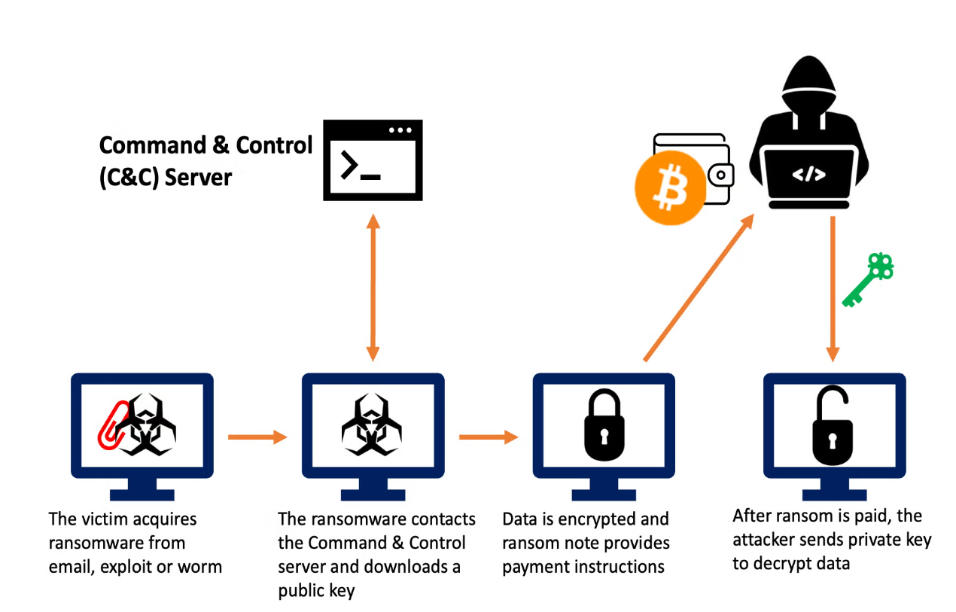

This project focuses on developing a comprehensive ransomware detection system using machine learning, deep learning, and hybrid models. By leveraging both structured and image datasets, we aim to design a system that can identify ransomware with high accuracy, minimizing false positives, and improving early detection. The reason for selecting this topic lies in the evolving nature of ransomware, which consistently outpaces traditional security measures. Employing advanced machine learning and deep learning models offers a more adaptive and effective solution to this growing threat.

1.2 The Significance and Motivation
Ransomware is not only a growing global concern but also a fast-evolving cyber threat that often bypasses conventional security tools. Traditional signature-based detection methods are ineffective against new or modified ransomware variants, leading to catastrophic data loss and operational disruptions. The need for a more intelligent and adaptive approach to ransomware detection is evident, and machine learning and deep learning offer promising solutions. These models can identify patterns in ransomware behavior that human analysis might miss.
The motivation for this project stems from the increasing frequency and sophistication of ransomware attacks, coupled with the insufficient defenses posed by legacy systems. By analyzing two distinct datasets, a structured dataset, and an image dataset, we aim to develop a robust detection mechanism to thwart ransomware before encryption occurs. The inclusion of a hybrid model — incorporating the strengths of both machine learning and deep learning — further enhances this system’s detection capability, which has not been commonly addressed in other studies, since most researchers have not explored the hybrid model approach for ransomware detection.

1.3 Aims and Objectives
The primary aim of this project is to create a highly effective ransomware detection system that combines machine learning and deep learning models to identify ransomware attacks. Specifically, we aim to:
1. Analyze and compare several machine learning and deep learning algorithms including: Random Forest ,(RF) Support Vector Machine (SVM), Naïve bias, KNN, CNN, RNN, ANN, LSTM, and Autoencoder, using two datasets (structured and image-based) to find the most effective models for ransomware detection.
2. Propose a new novel hybrid model that integrates the best-performing machine learning and deep learning algorithms to enhance detection accuracy and reduce false positives.
3. Implement the hybrid model within a user-friendly web application for practical use, enabling real-time ransomware detection for users and organizations.
4. Provide insights and recommendations on how future systems can leverage machine learning and deep learning models to detect ransomware efficiently.
By achieving these objectives, this project will contribute to the ongoing fight against ransomware, offering a scalable and adaptable solution that can protect against both known and unknown threats.

Literature Review
Over the past decade, numerous studies have explored the application of machine learning in the detection and classification of ransomware. These studies utilize both traditional ML algorithms and advanced DL techniques to improve detection accuracy and efficiency.
2.1 The previous studies and works
Masum et al. [1] propose a framework based on feature selection and machine learning algorithms for ransomware classification and detection. They apply several classifiers, including Decision Tree (DT), Random Forest (RF), Naïve Bayes (NB), Logistic Regression (LR), and Neural Networks (NN), on a selected set of features extracted from a ransomware dataset. The study emphasizes the importance of choosing the right features to enhance the performance of these classifiers.
The experimental results reveal that the Random Forest classifier outperforms other methods in terms of accuracy, F-beta score, and precision, with an accuracy of 99%. The authors demonstrate that feature selection, combined with robust machine learning models, can significantly improve the detection of ransomware while minimizing false positives. This study is an important contribution to the field, highlighting the efficiency of traditional ML algorithms like Random Forest when optimized with appropriate features.
Nanda Rani et al. [2] present a proof-of-concept model for ransomware detection, where they evaluate several machine-learning algorithms, including Decision Tree, Random Forest, KNN, SVM, XGBoost, and Logistic Regression. The authors focus on analyzing the efficiency of these algorithms through various metrics, such as precision, recall, and confusion matrix elements (TP, TN, FP, FN).
Their experiments achieve the highest accuracy (98.21%) using XGBoost, followed by Logistic Regression and Random Forest. The study also discusses the stages of ransomware attacks, particularly highlighting the importance of understanding the ransomware attack flow, which consists of distributed campaigns, code injection, encryption, and ransom demands. This research shows the effectiveness of modern ML algorithms in identifying ransomware based on its behavior, while also providing a detailed comparison of the performance of different classifiers.
Smith et al. [3] provide a comprehensive review of various machine learning algorithms and frameworks used for ransomware detection. The study covers both traditional machine learning models like Support Vector Machines (SVM) and Decision Trees, as well as advanced deep learning architectures like Artificial Neural Networks (ANNs) and Long Short-Term Memory (LSTM) networks. The authors highlight the challenges of detecting ransomware, which often uses sophisticated encryption techniques and evasion strategies, such as utilizing The Onion Router (TOR) networks to conceal communication with command-and-control servers.
The paper also discusses static and dynamic analysis techniques, emphasizing the limitations of signature-based detection systems, which are less effective against new ransomware variants. The review underscores the importance of combining ML algorithms with hybrid analysis frameworks to improve detection rates and reduce false positives.
Rani et al. [4] provides a comprehensive overview of machine learning techniques applied to ransomware detection. The authors emphasize the increasing sophistication of ransomware and the inefficacy of traditional signature-based detection methods in dealing with zero-day attacks. To address these challenges, they review various machine learning approaches, from traditional models such as Random Forest (RF), Support Vector Machine (SVM), and K-Nearest Neighbors (KNN), to more complex models like Long Short-Term Memory (LSTM) and Convolutional Neural Networks (CNN).
The study underscores the importance of selecting appropriate features for training machine learning models and highlights the potential of hybrid models, which combine static and dynamic analysis, for more effective ransomware detection.
Alriazza et al. [5] provided a detailed survey of ransomware detection techniques using machine learning. The authors present an analysis of the evolution of ransomware attacks and their increasingly complex nature, which has made detection more challenging. They discuss both traditional and modern ransomware-detection techniques, highlighting the limitations of signature-based methods and the growing importance of behavioral analysis and machine learning models.
The survey categorizes detection approaches into four types: signature-based, heuristic-based, network-based, and hybrid detection. Machine learning techniques, particularly Random Forest (RF), Support Vector Machines (SVM), and Decision Trees (DT), are identified as effective tools in improving detection rates.
Ahmed et al. [6] delves into the detection of Android ransomware using machine learning techniques applied to network traffic analysis. The authors utilize a publicly available dataset from Kaggle, comprising 392,035 records of benign traffic and 10 distinct types of Android ransomware. The study highlights the importance of feature selection, using forward feature selection and feature importance methods to narrow down the dataset to 19 crucial features. Several machine-learning models, including decision trees (DT), support vector machines (SVM), and k-nearest neighbors (KNN), were employed, alongside an ensemble model. The decision tree model achieved the highest accuracy of 97.24%, while SVM recorded a perfect recall of 100%, indicating strong detection capabilities. The study emphasizes the efficacy of network traffic analysis as a complementary approach to traditional static and dynamic ransomware detection methods.
Zakaria et al. [7] presented a novel machine learning framework for early ransomware detection by focusing on pre-encryption activities. The authors propose the Pre-Encryption Detection Algorithm (PEDA), which uses API call sequences to detect malicious behavior before encryption begins. They emphasize the significance of identifying the "pre-encryption boundary", a critical point in an attack when ransomware is about to start encrypting files. The framework employs a multi-layered detection system combining signature-based detection and behavior-based analysis, utilizing machine learning classifiers like Logistic Regression, Decision Trees, Random Forest, Gradient Boosted Trees, and Support Vector Machines (SVM). Among these, Gradient Boosted Trees and SVM achieved the highest accuracy, demonstrating strong performance in distinguishing ransomware from benign software. The study shows that API call analysis is an effective method for identifying ransomware early, allowing for proactive intervention before encryption occurs, thereby minimizing potential damage.
Ispahany et al. [8] present a comprehensive review of ransomware detection techniques, specifically focusing on the use of machine learning. The authors analyze various approaches to ransomware detection, including static and dynamic methods, with a particular focus on detecting ransomware at different stages of its lifecycle. They emphasize that most existing studies concentrate on detecting ransomware after encryption has begun, highlighting the need for real-time and pre-encryption detection mechanisms to minimize the damage caused by ransomware attacks. One of the novel contributions of the paper is the introduction of a detailed taxonomy for ransomware detection systems, which classifies approaches based on detection phases, feature types, and machine learning techniques.
The review also identifies significant limitations in existing literature, such as the absence of standardized datasets for evaluating and comparing models, which hinders reproducibility and consistency across studies. Furthermore, the paper discusses how the fast-evolving nature of ransomware requires more adaptive detection methods, as traditional models often struggle to keep pace with new attack vectors. The authors call for future research to address these limitations by developing more robust, scalable, and real-time ransomware detection systems. They also stress the importance of integrating early detection techniques to intercept ransomware before encryption, which remains an underexplored area in current research.
Herrera-Silva and Hernández-Álvarez [9] presented a dynamic feature dataset specifically designed for ransomware detection using machine learning algorithms. The authors utilize dynamic analysis in a controlled sandbox environment to extract behavioral features from ransomware samples. They focus on encryptor and locker ransomware, executing experiments that generate dynamic parameters and utilizing Cuckoo sandbox to gather data. The dataset comprises 2000 records and 50 selected features, which were identified as relevant and non-redundant for detecting ransomware. The machine learning models applied to this dataset, such as random forest, gradient boosted trees, and neural networks, achieved an impressive average accuracy of over 99%, highlighting the effectiveness of dynamic feature analysis in identifying ransomware before encryption occurs.

Ciaramella et al. [10] propose a deep learning-based approach for detecting ransomware, generic malware, and legitimate files. The method converts executable binaries into images and uses CNN models like Le-Net, AlexNet, and VGG16. The VGG16 model achieved the highest accuracy (96.9%) and precision (97%).
A key contribution of this work is the integration of the Grad-CAM algorithm, which enhances the explainability of the model by visually highlighting the parts of the input image that influence predictions. This makes the detection process more transparent, helping security analysts verify the model’s focus. The study stands out for combining high accuracy with an explainable deep learning approach, making it a valuable contribution to ransomware detection research.

3. Methodology
The goal of this research is to develop and evaluate a range of machine learning, deep learning, and hybrid models for detecting ransomware. The methodology involves multiple stages as shown in Figure 2, starting with data collection, preprocessing, and the implementation of various models on structured and image datasets. Two distinct datasets were employed, each of which required different preprocessing techniques and models to best exploit the unique characteristics of the data.
The following sections outline the datasets used, the preprocessing steps applied for each dataset, and the models implemented.
Figure 2. Methodology
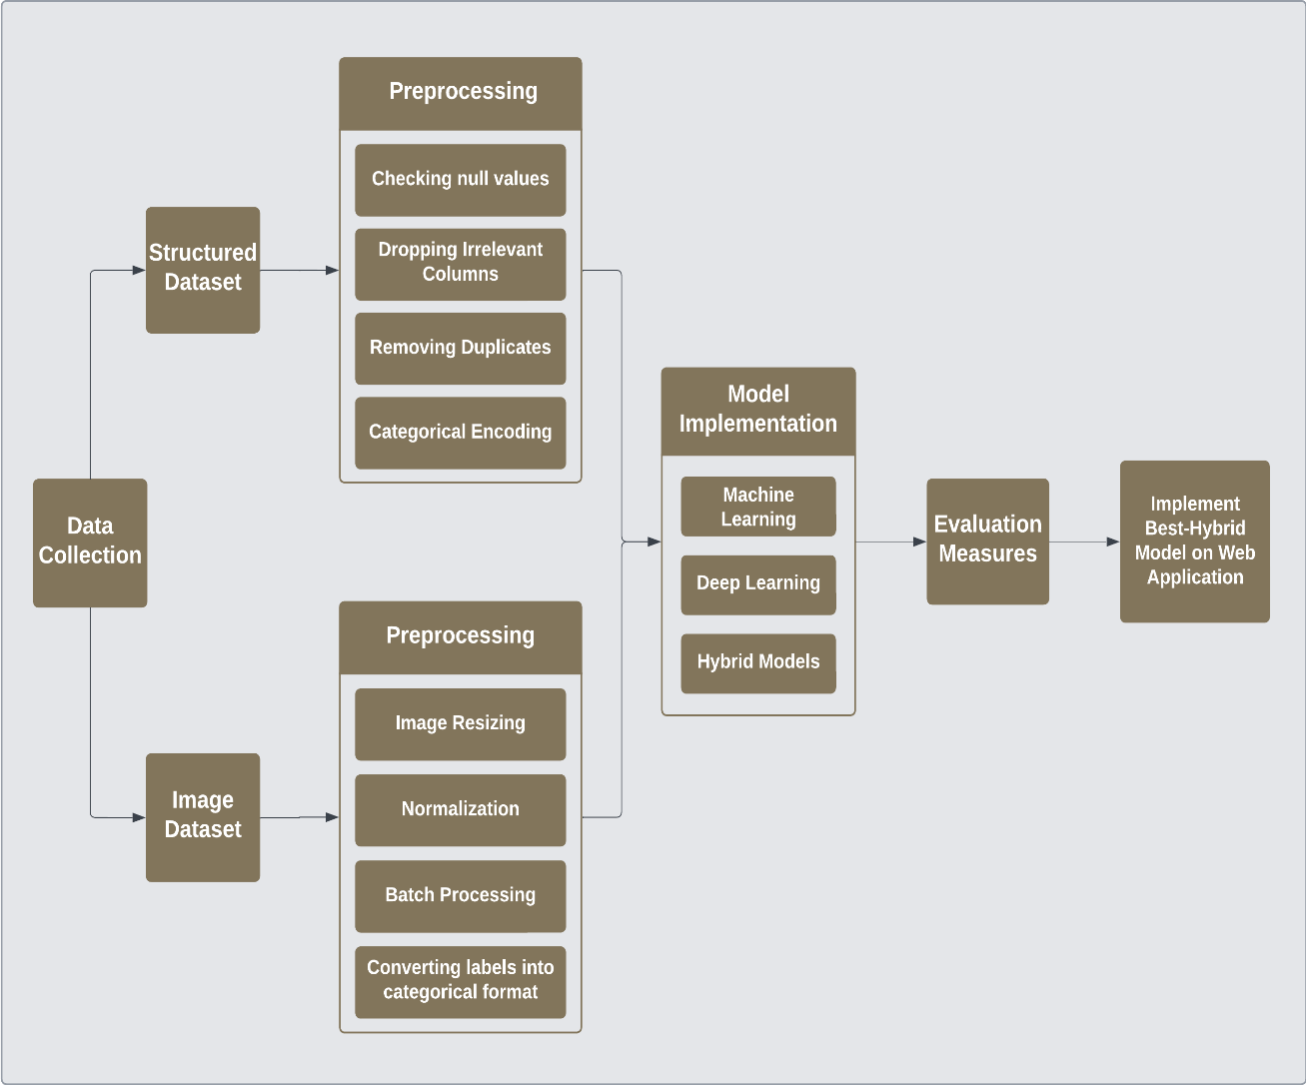
3.1. Structured Dataset
The first dataset used in this study is a structured ransomware detection dataset obtained from Kaggle [11]. It consists of metadata related to ransomware and benign samples, providing a comprehensive set of features for machine and deep model training.
The dataset consists of 18 features and 62,485 samples, with ransomware making up 56.60% and benign samples accounting for 43.40%. To maintain the same class distribution, stratified sampling was used to select a representative subset of 10,000 rows. This approach ensured that the ratio of benign (1) to ransomware (0) samples in the subset accurately reflected the proportions in the entire dataset as shown in Figure 3 for a sample of the dataset.
Figure 3. Dataset Sample
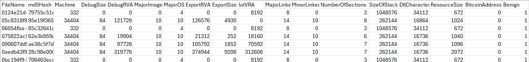
3.1.1 Feature Overview
The structured dataset includes a variety of attributes related to each file, such as machine identifiers, versioning details, and size information. These features were preprocessed and selected based on their relevance to ransomware detection.
Key columns include:
1. FileName: Useful for tracking and identifying files but may not directly contribute to ransomware detection.
2. md5Hash: Same as the last one, Helpful for file tracking and identification, but may not play a direct role in detecting ransomware.
3. Machine: Different architectures may have specific vulnerabilities.
4. DebugSize: Files with extensive debug information might be less likely to be malicious.
5. DebugRVA: Files that contain a large amount of debug information are generally considered less likely to be malicious.
6. MajorImageVersion: Older versions might be more vulnerable to certain types of attacks.
7. MajorOSVersion: Earlier versions could be more susceptible to specific types of attacks.
8. ExportRVA: Malware might export functions that are used to perform malicious actions.
9. ExportSize: Malware may provide functions that are utilized to carry out harmful activities.
10. IatVRA: Can indicate dependencies on potentially malicious libraries.
11. MajorLinkerVersion: May provide insights into the development environment and potentially identify commonalities between malware samples.
12. MinorLinkerVersion: It can offer insights into the development environment and help identify shared characteristics among different malware samples.
13. NumberOfSections: Malware might have more sections to hide malicious code.
14. SizeOfStackReserve: Could indicate the complexity of the program.
15. DllCharacteristics: Security features like ASLR (Address Space Layout Randomization) might be turned off in malicious files.
16. ResourceSize: Malware might include additional resources for its operation.
17. BitcoinAddresses: Directly related to ransomware; files with Bitcoin addresses are likely to be malicious.
18. Benign: Indicator whether the file is benign (1) or ransomware (0)
This structured dataset provided the foundation for training machine and deep learning approach.

3.1.2 Structured Dataset Preprocessing
The structured dataset consists of 62,485 entries with 18 columns. Several preprocessing steps were carried out to ensure the data was in the correct form for training machine learning models. Below are the steps performed on the dataset:
1. Checking null values:
No null values were detected in the dataset.
2. Dropping Irrelevant Columns:
The FileName and md5Hash columns were dropped, as they do not contribute directly to the detection of ransomware.
3. Categorical Encoding:
Several categorical features, such as Machine, DebugSize, NumberOfSections, SizeOfStackReserve, MajorOSVersion, and BitcoinAddresses, were converted into numerical values by encoding them into integer codes.
4. Removing Duplicates:
To ensure data integrity, duplicate rows were identified and removed.

3.1.3 Machine and Deep Learning Models for Structured Dataset
This section outlines the machine learning, deep learning, and hybrid models implemented for the structured dataset.
1. Machine Learning Models
In our research on the structured dataset, we employed several machine-learning algorithms, including Random Forest, Support Vector Machine (SVM), and Naive Bayes. For further details, please refer to Table 1 for more information about the used models.
Table 1. Machine learning models parameters for Structured dataset
Algorithm | Key Parameters
Random Forest Classifier | n_estimators=100, random_state=0
Support Vector Machine (SVM) | kernel='rbf', random_state=0
Gaussian Naive Bayes (NB) | nb_classifier= GaussianNB()

2. Deep Learning Models
We also implemented various deep learning models, including Recurrent Neural Network (RNN), Artificial Neural Network (ANN), Convolutional Neural Network (CNN), Long Short-Term Memory (LSTM), and Autoencoder, their parameters shown in Table 2 for more information about the used models.
Table 2. Deep learning models parameters for Structured dataset
Model Type | Input Shape | Activation Functions | Dropout Rates | Output Activation | Loss Function | Optimizer | Number of Layers
CNN | (Number of features, 1) | ReLU (Conv1D, Dense layers) | 0.3, 0.4 | Sigmoid | Binary Crossentropy | Adam | 9
RNN | (Number of features, 1) | Tanh (RNN layers)  ReLU (Dense layer) | 0.2 | Sigmoid | Binary Crossentropy | Adam | 7
ANN | (Number of features,) | ReLU (Dense layers) | 0.4, 0.3 | Sigmoid | Binary Crossentropy | Adam | 7
LSTM | (Number of features, 1) | Tanh (LSTM layers)  ReLU (Dense layer) | 0.2 | Sigmoid | Binary Crossentropy | Adam | 7
Autoencoder | (Number of features,) | ReLU (Dense layers) | 0.4, 0.3 | Sigmoid | Mean Squared Error (MSE) | Adam | 6

3. Hybrid Models
Additionally, we explored hybrid models by combining traditional machine learning algorithms (Random Forest and SVM) with deep learning techniques including CNN, RNN, ANN, LSTM, and Autoencoder models.
Table 3. Hybrid models parameters for Structured dataset
Model | Layer in Features Extraction | Dropout Rates | Activation Functions | Input Shape | Number of Layers
CNN - RF | Conv1D(64filters, kernel_size=3)  MaxPooling1D  Conv1D(32filters, kernel_size=3)  MaxPooling1D  Flatten  Dense(128 units) | 0.3, 0.4 | ReLU (Conv1D, Dense layers) | (Number of features, 1) | 9
RNN - RF | SimpleRNN(128units)  Dense(64 units) | 0.2 | Tanh (RNN layers)  ReLU (Dense) | (Number of features, 1) | 7
ANN - RF | Dense(256units)  Dense(128units)  Dense(64 units) | 0.4, 0.3 | ReLU (Dense layers) | (Number of features,) | 7
LSTM - RF | LSTM(128units)  Dense(64 units) | 0.2 | Tanh (LSTM)  ReLU (Dense) | (Number of features, 1) | 7
Autoencoder - RF | Dense(256units)  Dense(128units)  Dense(256 units) | 0.4, 0.3 | ReLU (Dense layers) | (Number of features,) | 6
CNN - SVM | Conv1D(64filters, kernel_size=3)  MaxPooling1D  Conv1D(32filters, kernel_size=3)  MaxPooling1D  Flatten  Dense(128 units) | 0.3, 0.4 | ReLU (Conv1D, Dense layers) | (Number of features, 1) | 9
RNN - SVM | SimpleRNN(128 units)  Dense(64 units) | 0.2 | Tanh (RNN layers)  ReLU (Dense) | (Number of features, 1) | 7
ANN - SVM | Dense(256units)  Dense(128units)  Dense(64 units) | 0.4, 0.3 | ReLU (Dense layers) | (Number of features,) | 7
LSTM - SVM | LSTM(128units)  Dense(64 units) | 0.2 | Tanh(LSTM)  ReLU (Dense) | (Number of features, 1) | 7
Autoencoder - SVM | Dense(256units)  Dense(128units)  Dense(256 units) | 0.4, 0.3 | ReLU (Dense layers) | (Number of features,) | 6

3.2 Image Dataset
The second dataset used in this study is an image dataset, also obtained from Kaggle [12]. This dataset consists of over 25,000 images representing ransomware and benign files. The ransomware samples are divided into 10 families according to Microsoft’s naming scheme, while the benign files are grouped under a single class.
Class Overview:
- Benign: This class contains files that are free from malware or ransomware. The files here represent regular, non-malicious software or data. No subdivision is done for different types of benign files in this dataset.
- BetterSurf: Typically categorized as adware or potentially unwanted program (PUP), not purely ransomware. It can hijack browsers, redirect searches, and display intrusive ads.
- Eksor.A: a ransomware family that encrypts user data and demands ransom for decryption. This family typically includes malware variants that spread via phishing emails or malicious links.
- Reveton.A: member of the "Police Trojan" family of ransomware. It locks the computer, displays fake messages from law enforcement, and demands payment for alleged illegal activities.
- The VB.IL: ransomware family encrypts files on the infected machine and demands a ransom for the decryption key. It is likely named for its use of Visual Basic (VB) scripting.
- Occamy.C: a type of Trojan that can steal data, execute malicious code, and potentially lock files. It can be used for a variety of malicious purposes, including data exfiltration.
- Sfone: is a lesser-known ransomware strain. It generally encrypts files and demands a ransom, but specific details are not widely documented.
- Obfuscator.AFQ: refers to a family of malware that uses obfuscation techniques to hide its true purpose from security detection systems. This family can facilitate other malicious actions, including ransomware.
- Zbot: also known as Zeus, is a notorious banking Trojan often used to steal financial data. Variants of Zbot may assist in deploying ransomware payloads.
- OnLineGames.CTB: is a ransomware strain that targets gaming files and systems. It encrypts files related to online games and demands a ransom.
- Zbot!CI: is a variant of the Zbot (Zeus) Trojan, designed for data theft and potentially used to deploy ransomware.
This dataset was specifically used for deep learning models, where CNNs were leveraged to automatically extract features from the images and classify ransomware from benign files. The visual nature of the data allowed the model to capture intricate details and patterns associated with different ransomware families.

3.2.1 Image Dataset Preprocessing
For the image dataset, we have applied several preprocessing steps to prepare the images for machine and deep learning model training. These steps were crucial in ensuring uniformity and consistency across the dataset:
- Rescaling: Normalizes pixel values to the range [0, 1].
- Image Resizing: The original size for the images was 128x128. All images were resized to a fixed dimension of 64x64 pixels to ensure uniformity across the dataset.
- Batch Processing: Processes images in batches of 32 for efficient computation.
- Class Mode: Converts labels into a categorical format suitable for multi-class classification.

3.2.2 Machine and Deep Learning Models for Image Dataset
In this section, we’ll describe machine learning, deep learning, and hybrid models applied to the image dataset.
1. Machine Learning Models
For machine learning, we implemented the Random Forest, Support Vector Machine (SVM), and K-Nearest Neighbors (KNN) models. please refer to Table 4 for more information about the used machine learning models.
Table 4. Machine learning models parameters for Image dataset
Classifier | Details
Feature Extraction | - Model Used: VGG16 (pre-trained on ImageNet).  - Output Features: 7x7x512 feature maps for each image.  - Reshape: Flatten the features into a 1D array for each image.  - Output Shape after Reshaping: (Number of samples, 25088)
Random Forest | - Parameters: `n_estimators=100`, `random_state=42`.
Support Vector Machine | - Parameters: `kernel='linear'`, `random_state=42`.
K-Nearest Neighbors | - Parameters: `n_neighbors=5`.

2. Deep Learning Models
In the deep learning category, we utilized the Convolutional Neural Network (CNN) and Recurrent Neural Network (RNN) models. please refer to Table 5 for more information about the used deep learning models.
Table 5. Deep learning models parameters for Image dataset
Model | Input Shape | Activation Functions | Dropout Rates | Output Activation | Loss Function | Optimizer | Epoch | Batch Size | Number Of Layers
CNN (VGG16) | (64, 64, 3) | ReLU, Softmax | 0.5 | Softmax | categorical_crossentropy | Adam | 10 | 32 | 3
RNN | (64, 64, 3) | ReLU | 0.5 | Softmax | categorical_crossentropy | Adam | 10 | 32 | 3

3. Hybrid Models
Additionally, we developed hybrid models, including RNN-KNN, RNN-Random Forest, and RNN-SVM combinations, as well as CNN-KNN, CNN-Random Forest, and CNN-SVM hybrids. please refer to Table 6 for more information about the used hybrid models.
Table 6. Hybrid models parameters for Image dataset
Model | Feature Extraction Layer | Activation Functions | Input Shape | Number of Layers | Classifier Details
CNN - KNN | VGG16 (Pre-trained) | N/A (Frozen Layers) | (64, 64, 3) | VGG16 + 1 (GlobalAveragePooling2D) | k=5, Euclidean distance
CNN - Random Forest | VGG16 (Pre-trained) | N/A (Frozen Layers) | (64, 64, 3) | VGG16 + 1 (GlobalAveragePooling2D) | 100 estimators, random_state=42
CNN - SVM | VGG16 (Pre-trained) | N/A (Frozen Layers) | (64, 64, 3) | VGG16 + 1 (GlobalAveragePooling2D) | Linear kernel, random_state=42
RNN - KNN | Sequential model (RNN Layers) | ReLU (Dense), Softmax (Output) | (64, 64, 3) | 4 | k=5, Euclidean distance
RNN - Random Forest | Sequential model (RNN Layers) | ReLU (Dense), Softmax (Output) | (64, 64, 3) | 4 | 100 estimators, random_state=42
RNN - SVM | Sequential model (RNN Layers) | ReLU (Dense), Softmax (Output) | (64, 64, 3) | 4 | Linear kernel, random_state=42

3.3 Description of software used:
In this research, several software tools and libraries were used to implement and evaluate machine learning, deep learning, and hybrid models for ransomware detection. Each tool played a crucial role in different stages of the project, from data preprocessing to model evaluation.
The primary environment for this research was Jupyter Notebook (version 6.5.4), produced by the Jupyter Project in 2023. Jupyter Notebook was chosen for its flexibility, allowing code, results, and documentation to be presented in an organized and interactive manner. This interactive environment facilitated the experimentation and visualization of model performance during development.
The programming language used throughout the project was Python (version 3.11.5), produced by the Python Software Foundation in 2023. Python was selected for its extensive library ecosystem, ease of use, and robust support for both machine learning and deep learning tasks. Python’s versatility allowed for rapid development, testing, and fine-tuning of the models.
For numerical operations, NumPy (version 1.24.3), an open-source project maintained by the Python Software Foundation, was utilized. NumPy was critical for handling large datasets, performing efficient array manipulations, and carrying out numerical computations required for processing both structured and image data.
To implement deep learning models, TensorFlow (version 2.17.0), developed by Google in 2023, was used. TensorFlow provided a comprehensive platform for building and training deep learning models, including Convolutional Neural Networks (CNNs) and Recurrent Neural Networks (RNNs). Its ability to handle large-scale computations and extensive support for neural networks made it indispensable for this research, particularly in constructing hybrid models that combined traditional machine learning with deep learning techniques.
For traditional machine learning tasks, Scikit-learn (version 2.0.3), developed by INRIA (the French National Institute for Research in Computer Science and Automation) in 2023, was employed. Scikit-learn was used to implement models such as Random Forest, Support Vector Machine (SVM), and K-Nearest Neighbors (KNN). It also provided essential tools for data splitting, feature scaling, and evaluation metrics (including accuracy, precision, recall, and F-Score). The library’s simplicity and its integration with Python made it highly effective for quickly implementing and testing machine learning algorithms.
Pandas (version 2.0.3), an open-source data manipulation library maintained by the Pandas Development Team in 2023, was utilized for handling and preprocessing the structured dataset. Pandas played a key role in loading data from CSV files, cleaning and organizing data, and performing feature selection. Its ability to manage large tabular datasets efficiently was critical to preparing the data for machine learning models.
Several built-in Python libraries were also essential for this research. The os, time, zipfile, and shutil libraries, which are part of the Python Standard Library, were used for tasks such as file and directory management, timing operations, and extracting zip files. These libraries were crucial during data preprocessing, as they enabled the automation of file handling and dataset organization.
Additionally, LabelEncoder, a component of Scikit-learn, was used to convert categorical data, such as ransomware family names, into numerical labels for use in model training. This was essential for both machine learning and deep learning models, which require numerical input data. The StandardScaler, another component of Scikit-learn, was applied to normalize and scale features, particularly for algorithms like SVM, which are sensitive to the magnitude of input data. Standardizing the feature values ensured that no single feature dominated the learning process due to its scale, improving model performance.
Together, these software tools and libraries enabled the development, training, and evaluation of a wide range of machine learning and deep learning models, offering flexibility, efficiency, and scalability throughout the research process.

4. Models Evaluation
4.1 Evaluation Metrics
In machine learning and information retrieval, there are various metrics to measure the different aspects of accuracy. For example, Recall is a measure that targets the completeness of detection. On the other hand, Precision measures the quality (or exactness) of detected Ransomware.
Our evaluation aims at providing a comprehensive analysis of various classifiers and accuracy measures to provide the flexibility to select the classifier whose accuracy specifications are most relevant to users (stakeholders). Therefore, we use the most popular accuracy measures in machine learning and information retrieval domains. We list these measures and explain each one next.
1. Accuracy: Accuracy was calculated as the primary metric to evaluate the overall performance of each machine learning model, providing a straightforward measure of how often the model's predictions were correct.
$$Accuracy=\frac{True Positives (TP) + True Negatives (TN)}{Total Instances}$$
2. Precision: Precision was used to assess the model's ability to avoid false positives, which is crucial in scenarios where incorrectly classifying a benign file as ransomware could have significant consequences.
$$Precision =\frac{True Positives (TP)}{(True Positives (TP) + False Positives (FP)}$$
3. Recall: Recall was used to evaluate the model's ability to correctly identify all ransomware files, which is important for minimizing the risk of leaving ransomware undetected.
$Recall=\frac{True Positives (TP)}{True Positives (TP) + False Negatives (FN)}$

4. F-Score: F-Score was used as a single metric to balance precision and recall, offering a more comprehensive view of model performance when there is a trade-off between these two metrics.
$F_Score =\frac{2 * (Precision * Recall)}{(Precision + Recall)}$
5. Training Time: Training time was recorded to assess the computational efficiency of each model. This metric is particularly important when considering the feasibility of deploying these models in real-time applications.
4.2 Experimental Results
After evaluating the models using the metrics outlined above, a comparison was made between machine learning, deep learning, and hybrid models. The comparison focused on the following aspects:
1. Performance based on using Structured Dataset:
Machine Learning vs. Deep Learning: A comparison of accuracy, precision, recall, and F-Score was made between machine learning models (Random Forest, SVM, Naive Bayes) and deep learning models (RNN, ANN, CNN, LSTM, Autoencoder). The performance of hybrid models was also evaluated to determine if they offered any improvement over standalone models.
2. Performance based on using Image Dataset:
Deep Learning vs. Hybrid Models: The accuracy and training time of deep learning models (CNN, RCNN) were compared against hybrid models (CNN-KNN, CNN-RF, CNN-SVM, RCNN-KNN, RCNN-RF, RCNN-SVM) to assess whether the hybrid approach provided any significant advantage.
3. Training Time Consideration:
Across all models, training time was considered to determine the feasibility of deploying each model in real-world applications. While deep learning and hybrid models generally required more computational resources and time, their performance was evaluated to see if the additional training time resulted in significantly better accuracy.

Results and Analysis
The following section presents the specific results obtained from applying machine learning, deep learning, and hybrid models to both the structured and image datasets. The results are organized according to the sequence followed in the Materials and Methods section, ensuring clarity and logical flow. The findings are related to the initial hypothesis, and comparisons with existing research are provided where relevant.
5.1 Results for Structured Dataset
The structured dataset was used to train and evaluate multiple machine learning, deep learning, and hybrid models. The performance metrics for each model are summarized below:
5.1.1 Machine Learning Models
The results of machine learning models included Random Forest, SVM, and Naive Bayes presented in Table 7.
Table 7. Machine learning Results for Structured dataset
Model | Accuracy | Precision | Recall | f-score | Training Time
Random Forest | 97% | 97% | 97% | 97% | 0.22
SVM Model | 95.5% | 95.5% | 95.5% | 95.4% | 0.01
Naive Bayes | 52% | 52.2% | 52% | 52% | 0.0033

As shown on the table, Random Forest achieved the highest accuracy, precision, recall, and F1-score among the machine learning models, confirming its effectiveness for structured data. SVM performed well, with slightly lower accuracy and recall compared to Random Forest, but it had a significantly faster training time. Naive Bayes, however, demonstrated limited effectiveness, showing lower accuracy and a higher propensity for misclassification, highlighting its limitations in this context.
5.1.2 Deep Learning Models
The results of deep learning models included CNN, RNN, ANN, LSTM, and Autoencoder are summarized in Table 8.
Table 8. Deep learning Results for Structured dataset
Model | Accuracy | Training Time
CNN | 97.40% | 27.47
RNN | 98.05% | 49.46
ANN | 98.10% | 18.24
LSTM | 97.40% | 88.52
Autoencoder | 68.97% | 17.12

The ANN model achieved the highest accuracy at 98.10% with the shortest training time of 18.24 seconds among the deep learning models, confirming its efficiency for structured data. RNN closely followed in accuracy but had a slightly longer training time, while both CNN and LSTM performed well but required more time to train, particularly the LSTM model. Although the Autoencoder was primarily employed for unsupervised learning and didn't reach the same accuracy levels, it proved effective in feature reduction.

5.1.3 Hybrid Models
The hypothesis posited that hybrid models would outperform standalone models due to their ability to combine the strengths of both machine learning and deep learning techniques. Table 9 presents the results for the hybrid models.
Table 9. Hybrid Model Results for Structured dataset
Model | Accuracy | Training Time
CNN - Random Forest | 99.05% | 13.84
RNN - Random Forest | 99.10% | 11.02
ANN - Random Forest | 99.15% | 9.63
LSTM - Random Forest | 98.90% | 10.75
Autoencoder- Random Forest | 99.05% | 17.61
CNN – SVM | 94.55% | 4.30
RNN – SVM | 96.85% | 1.66
ANN – SVM | 93.30% | 2.59
LSTM - SVM | 75.35% | 8.90
Autoencoder - SVM | 97.35% | 4.43

The Random Forest-ANN hybrid model achieved the highest accuracy at 99.15%, with a moderate training time, supporting the hypothesis that combining Random Forest with ANN enhances performance. Similarly, the Random Forest-RNN and Random Forest-CNN models also performed exceptionally well, highlighting the effectiveness of hybrid models. However, the SVM-LSTM model showed lower accuracy, indicating that not all hybrid combinations lead to performance gains, suggesting that careful selection of models in hybrid approaches is crucial.

5.2 Results for Image Dataset
The image dataset was evaluated using machine learning, deep learning, and hybrid models. The hypothesis was that deep learning models, particularly CNNs, would outperform machine learning models in image classification tasks.
5.2.1 Machine Learning Models
The machine learning models applied to the image dataset included Random Forest, SVM, and KNN. The results are presented in Table 10.
Table 10. Machine learning Results for Image dataset
Model | Accuracy | Precision | Recall | f1-score | Training Time
Random Forest | 94% | 94% | 94% | 93% | 95.6802
SVM | 94% | 93% | 94% | 93% | 114.173
KNN | 93% | 92% | 93% | 92% | 9.8212

Both Random Forest and SVM achieved high accuracy (0.94), with Random Forest slightly outperforming SVM in terms of training time, while KNN also performed well but showed slightly lower accuracy and faster training time compared to the other models.

5.2.2 Deep Learning Models
The deep learning models evaluated for the image dataset were CNN and RCNN. Table 11 summarizes their performance.
Table 11. Deep learning Results for Image dataset
Model | Accuracy | Training Time
CNN (VGG16) | 89.30% | 3225.64
RNN | 88.8% | 180.14

CNN (VGG16) achieved an accuracy of 89.30%, but it required a significantly longer training time of 3225.64 seconds, highlighting its effectiveness for image data despite the higher computational cost. RNN delivered a comparable accuracy of 88.8%, with a faster training time of 180.14 seconds, making it a potential alternative when prioritizing computational efficiency without sacrificing much accuracy.

5.2.3 Hybrid Models
The hybrid models evaluated combined CNN or RNN with traditional machine learning algorithms. The results are presented in Table 12.
Table 12. Hybrid Model Results for Image dataset
Model | Accuracy | Training time
CNN (VGG16) - KNN | 92.52% | 648.33
CNN (VGG16) – RF | 94.32% | 676.92
CNN (VGG16) - SVM | 93.24% | 677.36
RNN - KNN | 89.98% | 16.40
RNN - RF | 91.92% | 38.85
RNN - SVM | 88.06% | 36.18

The hybrid model combining CNN (VGG16) and Random Forest achieved the highest accuracy at 94.32%, highlighting the benefit of integrating CNN with traditional machine learning models for enhanced performance. The CNN (VGG16) - SVM model followed closely, with an accuracy of 93.24%, although it had a slightly longer training time of 677.36 compared to the Random Forest variant. The CNN (VGG16) - KNN model also performed well, achieving 92.52% accuracy with a shorter training time of 648.33. For RNN-based models, the RNN - KNN hybrid achieved 89.98% accuracy with a notably faster training time of 16.40, while the RNN - RF model attained 91.92% accuracy with a training time of 38.85. Meanwhile, the RNN - SVM hybrid had the lowest accuracy at 88.06%, paired with a longer training time of 36.18.
5.3 Discussion of Results
The results demonstrate that hybrid models consistently outperformed their standalone counterparts across both structured and image datasets. For the structured dataset, the ANN – Random Forest hybrid model achieved the highest accuracy of 99.15%, with a relatively short training time, making it the top-performing model. Other hybrid models like RNN – Random Forest and CNN – Random Forest also delivered impressive accuracy above 99%, while deep learning models such as ANN and RNN showed strong performance, though with longer training times.
In the case of the image dataset, the CNN (VGG16) – Random Forest hybrid model achieved the highest accuracy of 94.32%, followed closely by the CNN (VGG16) – SVM with 93.24%. Although standalone deep learning models like offered solid classification accuracy around 89.3%, they required significantly longer training times, making hybrid models a more efficient choice.
Overall, the combination of machine learning and deep learning proved highly effective for handling complex data, offering an optimal balance between accuracy and computational efficiency. The robustness of hybrid models suggests they are particularly well-suited for tasks requiring both speed and precision, such as real-time ransomware detection scenarios.

6. Web Deployment
After selecting the best-performing hybrid models for both the structured and image datasets, these models were integrated into a web application to allow users to interact with the system and make predictions. The web application was built using Flask as the web framework, with the user interface providing a simple and intuitive file upload feature for input data. Below is a detailed overview of the deployment process and the user experience.
6.1 Tools
The technical tools and technologies used in developing this web application were selected to ensure seamless integration of machine learning models into the user interface while maintaining ease of deployment and scalability. The web application is built on Flask, a lightweight Python-based web framework that offers both flexibility and simplicity. Flask was chosen primarily because of its straightforward integration with Python, which allowed the machine learning models to be easily incorporated into the backend.
In terms of programming languages, Python was used for the backend model handling and prediction processing, while HTML and JavaScript were employed for the front-end user interface. Machine learning models were created using popular libraries such as Scikit-learn, TensorFlow, and Keras, which provide robust frameworks for building, training, and deploying models.
6.2 web design and User interface
The user interface of the web application was designed with ease of use as a priority, ensuring that users can interact with the system without any prior technical expertise. The primary feature of the interface is the file upload mechanism, which is visually simple and intuitive. Users can either drag and drop their files into a designated area or manually browse their devices to select the appropriate files (see Figure 4 and 5). This functionality ensures flexibility and convenience, reducing the barriers to interacting with the system.

Figure 4. Drag and Drop
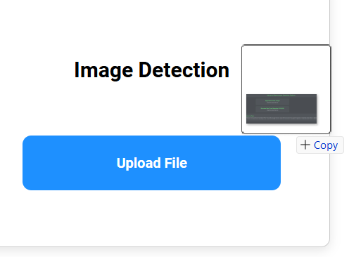

Figure 5. Manually Browsing
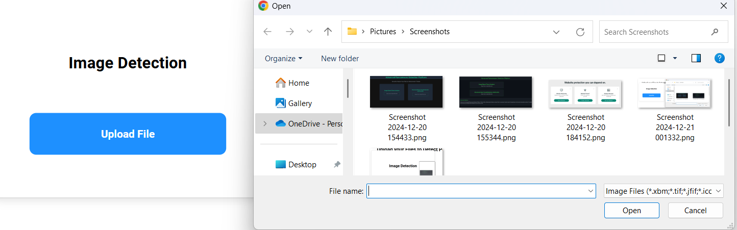

The interface also provides support for two types of input formats: structured data and image data. Structured data is uploaded in the form of CSV files, which contain the necessary attributes for ransomware classification, while image data is uploaded as PNG, JPEG, or JPG files (see Figure 6). The system’s versatility in accepting these different file types allows it to serve a broader range of use cases, making it more adaptable to various user needs.

Figure 6. Accepted Formats

Once a file is uploaded, the system processes the input and displays the results clearly and concisely. For structured data, the output includes whether the file is classified as ransomware or benign, along with the confidence level of the prediction. For image data, the result specifies the ransomware family to which the file belongs or indicates whether the file is benign. This output is designed to be easily understandable as shown in Figure 7, ensuring that users can quickly assess the results and make decisions based on the system's predictions.
Figure 7. Results Display


Conclusion and Recommendations
7.1 Conclusion
This project successfully developed several hybrid ransomware detection models by leveraging machine learning (ML), deep learning (DL), and hybrid approaches. Among the various models evaluated across two distinct datasets—a structured dataset and an image-based dataset—the top-performing models were the ANN with Random Forest for the structured dataset and CNN with Random Forest for the image dataset. These hybrid models significantly enhanced the accuracy and robustness of ransomware detection, outperforming standalone models in both datasets. These results affirm the efficacy of hybrid models in combining the strengths of ML and DL to detect ransomware more efficiently, minimizing false positives and improving detection speed. The system was successfully implemented in a user-friendly web application, enabling ransomware detection for both text-based and image-based data.
The research not only demonstrated the potential of hybrid models but also contributed to the broader field of cybersecurity by providing a scalable, adaptable, and highly accurate solution to detect and prevent ransomware attacks. The dual-approach methodology—integrating both structured and image data—proved effective in addressing the complexities of modern ransomware, which often evades traditional security measures.
7.2 Recommendations and Future Work
To further enhance the system, future work should focus on several key areas. First, exploring additional hybrid combinations of ML and DL algorithms could lead to more effective configurations, optimizing the balance between accuracy and computational efficiency. Furthermore, testing the model on alternative or larger datasets, such as real-time network traffic or datasets encompassing a wider variety of ransomware families, would help improve the model's robustness and generalizability across different ransomware types. As ransomware continues to evolve, it is also critical to enhance security features by incorporating threat intelligence data and behavioral analysis techniques, which would allow for the detection of zero-day attacks and anomalies before ransomware encryption occurs. Additionally, expanding the web application’s user interface to provide detailed reports and real-time threat notifications would improve accessibility for non-technical users, making the system more practical for broader use. Implementing these enhancements will not only strengthen the current system but also contribute to a more adaptable and comprehensive solution to the growing ransomware threat.

References
[1] M. Masum, M. J. H. Faruk, H. Shahriar, K. Qian, D. Lo, and M. I. Adnan, "Ransomware Classification and Detection With Machine Learning Algorithms", Kennesaw State University, USA, and United International University, Bangladesh, 2022.
[2] N. Rani and S. V. Dhavale, "Leveraging Machine Learning for Ransomware Detection", Defence Institute of Advanced Technology, Pune, India, 2022.
[3] D. Smith, S. Khorsandroo, K. Roy, "Machine Learning Algorithms and Frameworks in Ransomware Detection", North Carolina A&T State University, USA, 2022​.
[4] N. Rani, S. V. Dhavale, A. Singh, and A. Mehra, "A Survey on Machine Learning-based Ransomware Detection", Defence Institute of Advanced Technology, Pune, India, Persistent Systems, Pune, India, and National Critical Infrastructure Protection Centre, Mumbai, India, 2022.
[5] A. Alraizza and A. Algarni, "Ransomware Detection Using Machine Learning: A Survey", King Khalid University, Alfara, Saudi Arabia, 2023.
[6] A. Albin Ahmed, A. Shaahid, F. Alnasser, S. Alfaddagh, S. Binagag, and D. Alqahtani, "Android Ransomware Detection Using Supervised Machine Learning Techniques Based on Traffic Analysis", Imam Abdulrahman Bin Faisal University, Saudi Arabia, 2024​.
[7] W. Z. A. Zakaria, M. F. Abdollah, O. Abdollah, S. M. W. Mohamed, "Ransomware Early Detection using Machine Learning Approach and Pre-Encryption Boundary Identification", MyCERT, Cybersecurity Malaysia, Universiti Teknikal Malaysia Melaka, 2024.
[8] J. Ispahany, MD. R. ISLAM, MD.Z. ISLAM, and M. A. KHAN, "Ransomware Detection Using Machine Learning: A Review, Research Limitations and Future Directions," Cyber Security Cooperative Research Centre, Kingston, ACT, Australia, and Charles Sturt University, NSW, Australia, 2024​.

[9] J. A. Herrera-Silva and M. Hernández-Álvarez, "Dynamic Feature Dataset for Ransomware Detection Using Machine Learning Algorithms", Escuela Politécnica Nacional, Quito, Ecuador, 2023.
[10] G. Ciaramella, G. Iadarola, F. Martinelli, F. Mercaldo, and A. Santone, "Explainable Ransomware Detection with Deep Learning Techniques," Journal of Computer Virology and Hacking Techniques, 2024.
[11] https://www.kaggle.com/datasets/amdj3dax/ransomware-detection-data-set
[12] https://www.kaggle.com/datasets/maxsloof/thesis-data

